SPENDWISE – PERSONAL FINANCE & SAVINGS MANAGEMENT SYSTEM
A PROJECT REPORT
Submitted by
THIVYASRI T
2116240701571
in partial fulfilment of the End Semester Examination for the course
CB23F35 –
LOW-CODE APPLICATION DEVELOPMENT USING ZOHO CREATOR
in
BACHELOR OF ENGINEERING
COMPUTER SCIENCE AND ENGINEERING

RAJALAKSHMI ENGINEERING COLLEGE
(An Autonomous Institution, Affiliated to Anna University, Chennai)
Rajalakshmi Nagar, Thandalam, Tamil Nadu – 602 105
NOVEMBER 2026

RAJALAKSHMI ENGINEERING COLLEGE
(An Autonomous Institution, Affiliated to Anna University, Chennai)
BONAFIDE CERTIFICATE
Certified that this project report titled "SPENDWISE – PERSONAL FINANCE & SAVINGS MANAGEMENT SYSTEM" is the bonafide work of THIVYASRI T (2116240701571), who carried out the individual project work on the Zoho Creator low-code platform for the course CB23F35 - Low-Code Application Development using Zoho Creator, during the academic year 2026 2027, Semester V, under my supervision.

SIGNATURE  ________________________  HEAD OF THE DEPARTMENT  Department of Computer Science and Engineering  Rajalakshmi Engineering College | SIGNATURE  ________________________  COURSE FACULTY  Department of Computer Science and Engineering  Rajalakshmi Engineering College

Submitted for the End Semester Examination (Individual Project) held on ____________________.

INTERNAL EXAMINER | EXTERNAL EXAMINER

DECLARATION
I, THIVYASRI T (2116240701571) , hereby declare that the project report titled "SPENDWISE – PERSONAL FINANCE & SAVINGS MANAGEMENT SYSTEM", submitted for the End Semester Examination of CB23F35 - Low-Code Application Development using Zoho Creator, documents my individual work on the SpendWise application. The descriptions refer to the modules developed in Zoho Creator. Features that are planned but not yet completed, such as the AI prediction model and the additional workflow notifications, are not represented as completed.
I further declare that this report has not been submitted for any other degree or course credit. I acknowledge the prescribed college report template, Zoho Creator platform documentation, academic references, and any relevant AI-assisted drafting or development support used during preparation.

Place: Chennai
Date: 11- 11- 2026
SIGNATURE OF THE STUDENT
THIVYASRI T
2116240701571

ACKNOWLEDGEMENT
I express my sincere gratitude to the management of Rajalakshmi Engineering College for providing an academic environment and facilities supporting hands-on application development.
I thank the Principal of Rajalakshmi Engineering College for encouraging practical and industry-oriented learning.
I am grateful to the Head of the Department, Computer Science and Engineering, for the facilities and support provided during the course.
I offer my sincere thanks to my course faculty for guidance in the course CB23F35 and for encouraging the use of Zoho Creator to implement a complete application.
I acknowledge Zoho Corporation for the Zoho Creator platform and public documentation. I also thank my family and friends for their support.

THIVYASRI T

ABSTRACT
Managing personal finances manually is difficult because income, expenses, budgets and savings information are often scattered across notebooks, messages and separate spreadsheets. Users find it hard to monitor spending habits, identify unnecessary expenses and judge whether they are staying within their budgets. SpendWise – Personal Finance & Savings Management System is a low-code application developed using Zoho Creator to provide a centralized and automated solution to this problem.
The application contains four primary data modules: Expenses, Income, Monthly Budget and Savings Goals. Expense records store the expense name, amount, date, category and payment method; budget records store the budget name, month, year, budget amount and alert threshold. Two reports, All Expenses and All Incomes, display the stored transactions. A Home Page Navigation Hub provides access to application features, and an Analytics Dashboard presents charts of income, expenses and spending patterns. A workflow sends an email titled "SpendWise Alert: New Expense Recorded" whenever a new expense is saved. The application has been developed and tested with sample financial records and has reached Production Version 1.0 in Zoho Creator's Environment Management system.
The project is being extended with Zoho Creator's AI Modeler. A Prediction model is planned that will learn from historical expense records, using category, date and payment method, to predict an expense amount. This model still needs to be configured, trained, tested and integrated, and is therefore documented as planned work rather than a completed feature. Further planned enhancements include high-expense alerts, budget warnings at 80% and 100% of the monthly budget, savings goal completion alerts, periodic summary emails, multi-currency support and PDF report exports.
Keywords: Low-Code Development; Zoho Creator; Personal Finance Management; Budget Tracking; Savings Goals; Workflow Automation; Dashboard Analytics; AI Prediction.

PROJECT AT A GLANCE
Attribute | Details
Project Title | SpendWise – Personal Finance & Savings Management System
Application Domain | Personal Finance / Budgeting
Student Name & Register No. | Thivyasri T (240701571)
Zoho Creator Edition | Trial shown in screenshots; exact paid edition not verified
Application Name (Link Name) | https://creator.zoho.in/userhome/thivyasri.t.2024.cse_raja769/admindashboard#/
Published / Live URL | https://creatorapp.zoho.in/thivyasri.t.2024.cse_raja769/spendwise#Form:Expenses
Demo Credentials (per role) | Authenticated developer access; no credentials disclosed
Number of Forms / Subforms | 4 forms (Expense, Income, Monthly Budget, Savings Goals)
Number of Reports (by type) | 2 list reports (All Expenses, All Incomes)
Number of Pages / Dashboards | 2 (Home Page Navigation Hub, Analytics Dashboard)
Number of Workflows | 1 implemented (new-expense email notification); 3 planned
Deluge Functions / Custom Actions | No source or workflow editor evidence supplied
Integrations | None evidenced; AI Modeler (Prediction) planned
Roles & Profiles Defined | Process roles conceived; configured profiles unverified
Environments Used | Development and Production (Environment Management)
Date of Production Deployment | 30- 10- 2026 (Production Version 1.0)

TABLE OF CONTENTS
Section | Title | Page No.
 | ABSTRACT | iv
 | PROJECT AT A GLANCE | v
 | LIST OF TABLES | ix
 | LIST OF FIGURES | x
 | LIST OF ABBREVIATIONS | xi
1 | INTRODUCTION | 1
1.1 | Background | 1
1.2 | Problem Statement | 1
1.3 | Objectives | 1
1.4 | Scope of the Project | 2
1.5 | Justification for a Low-Code Approach | 2
1.6 | Organisation of the Report | 2
2 | LITERATURE SURVEY AND SYSTEM STUDY | 3
2.1 | Study of the Existing System | 3
2.2 | Limitations of the Existing System | 3
2.3 | Low-Code versus Traditional Development | 3
2.4 | Literature Survey | 4
2.5 | Emerging Trends in Low-Code Development | 4
2.6 | Proposed System | 4
3 | REQUIREMENT ANALYSIS | 5
3.1 | Stakeholders and User Roles | 5
3.2 | Functional Requirements | 5
3.3 | Non-Functional Requirements | 5
3.4 | Hardware and Software Requirements | 6
3.5 | Use Case Model | 6
4 | SYSTEM DESIGN | 7
4.1 | System Architecture | 7
4.2 | Data Model | 7
4.3 | Form Design | 8
4.4 | Process and Workflow Design | 8
4.5 | User Interface and Navigation Design | 9
4.6 | Access Control Design | 9
5 | IMPLEMENTATION | 10
5.1 | Application Setup | 10
5.2 | Forms and Data Capture | 10
5.3 | Reports | 11
5.4 | Pages and Dashboards | 11
5.5 | Deluge Scripting | 12
5.6 | Workflows and Automation | 12
5.7 | Integrations | 13
5.8 | User Management and Role-Based Access | 13
5.9 | AI and Analytics Features | 13
5.10 | Pro-Code Extension | 14
5.11 | Mobile and Portal Access | 14
6 | TESTING AND DEBUGGING | 15
6.1 | Testing Strategy | 15
6.2 | Test Cases | 15
6.3 | Debugging Deluge Scripts | 15
6.4 | Defect Log | 16
6.5 | User Acceptance Testing | 16
7 | DEPLOYMENT, SECURITY AND GOVERNANCE | 17
7.1 | Environments and Deployment Strategy | 17
7.2 | Performance Optimisation | 17
7.3 | Security Features | 17
7.4 | Governance and Administration | 18
8 | RESULTS AND DISCUSSION | 19
8.1 | Application Output | 19
8.2 | Achievement of Objectives | 20
8.3 | Comparison with the Existing System | 20
8.4 | Limitations of the Low-Code Approach | 21
8.5 | Reflection on the No-Code → Low-Code → Pro-Code Spectrum | 21
9 | CONCLUSION AND FUTURE ENHANCEMENTS | 22
9.1 | Conclusion | 22
9.2 | Future Enhancements | 22
9.3 | Learning Outcomes and Career Relevance | 22
 | REFERENCES | 23
 | APPENDIX A – ZOHO CREATOR FEATURE COVERAGE CHECKLIST | 24
 | APPENDIX B – COURSE OUTCOME MAPPING | 26
 | APPENDIX C – COMPLETE DELUGE SOURCE CODE | 27
C.1 | Confirmed custom script inventory | 27
C.2 | Proposed automation extensions (not implemented) | 27
 | APPENDIX D – USER MANUAL | 28
D.1 | Accessing the Application | 28
D.2 | Instructions for the End User | 28
D.3 | Instructions for the Administrator | 28
 | APPENDIX E – EVALUATION RUBRIC | 29
 | APPENDIX F – VIVA-VOCE RECORD SHEET | 30

LIST OF TABLES
Table 2.1: Comparison of Low-Code and Traditional Development for the Proposed Application
Table 2.2: Summary of Literature Survey
Table 3.1: Stakeholders and User Roles
Table 3.2: Functional Requirements
Table 3.3: Non-Functional Requirements
Table 3.4: Hardware and Software Requirements
Table 3.5: Use Case Description - Record an Expense
Table 4.1: Entities and Relationships
Table 4.2: Field Specifications
Table 4.3: Role–Permission Matrix
Table 5.1: Reports Implemented
Table 5.2: Deluge Scripts
Table 5.3: Workflows
Table 5.4: Integrations
Table 6.1: Test Cases
Table 6.2: Defect Log
Table 6.3: User Acceptance Feedback
Table 7.1: Deployment Checklist
Table 7.2: Performance Optimisation
Table 7.3: Security Controls
Table 8.1: Mapping of Objectives to Outcomes
Table 8.2: Existing System versus Proposed Application
Table A.1: Feature Coverage Checklist
Table B.1: Mapping of Course Outcomes to Report Chapters
Table E.1: Evaluation Rubric for the Individual Project
Table E.2: Performance Level Descriptors
Table F.1: Viva-Voce Questions and Responses
Table F.2: Marks Summary

LIST OF FIGURES
Figure 2.1: Existing Personal Finance Management Process
Figure 3.1: SpendWise Use Case Model
Figure 4.1: SpendWise Layered Architecture
Figure 4.2: Entity-Relationship Model
Figure 4.3: Expense Recording and Alert Process
Figure 4.4: Navigation Structure of SpendWise
Figure 5.1: Home Page Navigation Hub
Figure 5.2: Expense Form
Figure 5.3: Monthly Budget Form
Figure 5.4: All Expenses Report
Figure 5.5: All Incomes Report
Figure 5.6: Analytics Dashboard
Figure 5.7: Email Notification Workflow
Figure 5.8: Email Received: SpendWise Alert
Figure 5.9: AI Modeler - Planned Prediction Model
Figure 7.1: Environment Management - Production Version 1.0
Figure 8.1: Scenario Step 1 - Add an Expense
Figure 8.2: Scenario Step 2 - Records in Reports
Figure 8.3: Scenario Step 3 - Dashboard Update and Alert

LIST OF ABBREVIATIONS
Abbreviation | Expansion
AI | Artificial Intelligence
API | Application Programming Interface
CRUD | Create, Read, Update, Delete
ER | Entity-Relationship
FR | Functional Requirement
KPI | Key Performance Indicator
LCAP | Low-Code Application Platform
NFR | Non-Functional Requirement
RBAC | Role-Based Access Control
SDLC | Software Development Life Cycle
UAT | User Acceptance Testing
UI | User Interface
URL | Uniform Resource Locator

CHAPTER 1

INTRODUCTION

1.1 Background
Personal finance management involves recording income and expenses, planning monthly budgets and working towards savings goals. Many individuals handle these tasks with paper notes, memory or scattered spreadsheets, which makes it hard to see the overall financial picture. SpendWise – Personal Finance & Savings Management System is a low-code application developed using Zoho Creator to help users manage their personal finances in one place.
The application provides a centralized platform for organizing financial information. It uses forms to collect financial records, reports to display stored information, dashboards to visualize financial activities, and workflows to automate notifications. The project also aims to incorporate Artificial Intelligence (AI) and analytics to identify spending patterns and generate predictions that can assist users in making better financial decisions.

1.2 Problem Statement
Managing personal finances manually can be difficult because income, expenses, budgets and savings information may be scattered across different records. Users may also find it difficult to monitor their spending habits, identify unnecessary expenses and determine whether they are staying within their budgets. SpendWise addresses these challenges by providing a centralized and automated personal finance management system.
- Financial information is scattered across different records.
- Spending habits and unnecessary expenses are hard to identify.
- It is difficult to know whether spending is within the planned monthly budget.
- Savings progress is not tracked against defined goals.

1.3 Objectives
- To develop a centralized personal finance management application.
- To record and organize income and expenses.
- To create and monitor monthly budgets.
- To track savings goals and progress.
- To generate reports and visual dashboards.
- To automate notifications using workflows.
- To incorporate AI-based prediction and analytics.
- To improve financial awareness and budgeting decisions.

1.4 Scope of the Project
In scope: expense management; income management; monthly budget management; savings goals; the All Expenses and All Incomes reports; a Home Page Navigation Hub; an Analytics Dashboard; an email notification when a new expense is recorded; and deployment as Production Version 1.0 in Zoho Creator.
Planned / not yet complete: the AI Modeler Prediction model (to be configured, trained, tested and integrated); high-expense alerts; monthly budget warnings; savings goal completion alerts; automated weekly or monthly summary emails; multi-currency support; and PDF report exports.

1.5 Justification for a Low-Code Approach
Zoho Creator supplies native forms, linked records, reports, pages, workflows and hosting within a single low-code platform. This suits a personal finance application, where the main challenge is consistent data capture, clear reporting and timely alerts rather than a highly customized backend. It permits changes to the data structure, dashboards and notifications without building a separate frontend, database server and deployment pipeline, and it provides access to Deluge scripting and the AI Modeler when more advanced logic is required.

1.6 Organisation of the Report
Chapter 2 reviews the existing system and related low-code literature. Chapter 3 presents the requirement analysis. Chapter 4 describes the system design. Chapter 5 details the implementation on Zoho Creator. Chapter 6 covers testing and debugging. Chapter 7 discusses deployment, performance optimisation, security and governance. Chapter 8 presents results and discussion, and Chapter 9 concludes the report with future enhancements.
CHAPTER 2

LITERATURE SURVEY AND SYSTEM STUDY

2.1 Study of the Existing System
In a typical manual process, a person notes expenses in a diary or phone notes, keeps income details in a separate spreadsheet, and estimates the monthly budget mentally. Savings targets are tracked informally, if at all. This baseline is a typical process model rather than an audit of a particular individual.
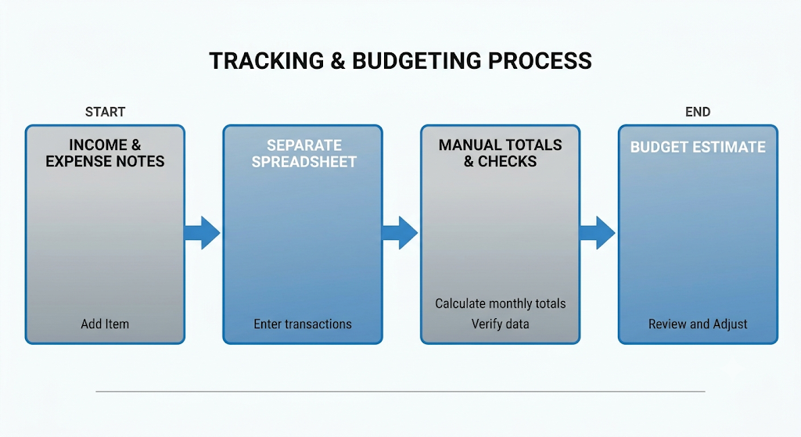
Figure 2.1: Existing Personal Finance Management Process

2.2 Limitations of the Existing System
- Records are scattered, so there is no single view of income, expenses and savings.
- Comparing actual spending with a planned budget requires manual calculation.
- Overspending is noticed only after the fact, because there are no automatic alerts.
- Spending patterns by category or payment method are difficult to identify without charts.

2.3 Low-Code versus Traditional Development
Table 2.1: Comparison of Low-Code and Traditional Development for the Proposed Application
Criterion | Traditional (Pro-Code) Development | Low-Code on Zoho Creator
Time to initial UI | Build API, schema and dashboards separately | Configure forms, reports and pages
Skills | Programming and deployment skills | Visual design and optional Deluge
Hosting | Independent server / application hosting | Creator-hosted browser runtime
Automation | Write and schedule custom backend jobs | Workflows and Deluge within the platform
AI features | Build and host a separate ML service | Zoho Creator AI Modeler (planned)
Maintenance | Changes across multiple layers | Edit form / report settings centrally
Customization | Extensive framework flexibility | Native controls; specialist UI constrained
Cost | Infrastructure plus development effort | Subscription / trial dependent

2.4 Literature Survey
Table 2.2: Summary of Literature Survey
S.No. | Author(s) / Source & Year | Title / Product | Key Findings | Relevance to this Project
1 | Zoho Corporation [1] | Creator forms | Forms capture data that feeds reports and workflows | Expense, Income, Budget and Goal forms
2 | Zoho Corporation [2] | Deluge script in form workflows | Form events can trigger scripted actions and notifications | New-expense email alert
3 | Bucaioni et al., 2022 [3] | Modelling in low-code development | Model-driven / visual development is central to low-code | Basis for entity modelling
4 | Pinho et al., 2023 [4] | Usability in low-code platforms | User-centred design affects usability | Home page and dashboard design

2.5 Emerging Trends in Low-Code Development
Research describes visual modelling, reusable components and citizen development as major drivers of low-code adoption. SpendWise applies these principles through configured data forms, report views and dashboard charts. AI-assisted features are another significant trend; SpendWise plans to use the Zoho Creator AI Modeler to predict expense amounts from historical records, but this feature is not yet complete.

2.6 Proposed System
The proposed system stores expense, income, monthly budget and savings goal records in Zoho Creator. Reports present the stored transactions, a Home Page Navigation Hub gives quick access to actions such as adding a new expense, and the Analytics Dashboard summarizes income, expenses and spending patterns. A workflow emails the user when a new expense is recorded, and an AI prediction model is planned to support financial planning. These elements address the fragmentation and lack of visibility in a manual process.
CHAPTER 3

REQUIREMENT ANALYSIS

3.1 Stakeholders and User Roles
Table 3.1: Stakeholders and User Roles
Role | Description | Key Responsibilities in the Application
End User | Individual managing personal finances | Record income and expenses; create budgets; define savings goals; view reports and dashboard
Application Owner | Developer / administrator | Maintain forms, reports, pages, workflows and the AI model; manage deployment

3.2 Functional Requirements
Table 3.2: Functional Requirements
FR ID | Requirement | Role(s) | Priority
FR-01 | Record expenses with name, amount, date, category and payment method | End User | High
FR-02 | Record income from different sources | End User | High
FR-03 | Create monthly budgets with name, month, year, amount and alert threshold | End User | High
FR-04 | Define savings goals and monitor progress | End User | High
FR-05 | Display All Expenses and All Incomes reports | End User | High
FR-06 | Provide a home page for navigation and quick actions | End User | High
FR-07 | Show an analytics dashboard with financial charts | End User | High
FR-08 | Send an email alert when a new expense is recorded | System | High
FR-09 | Send high-expense, budget-warning and goal-completion alerts (planned) | System | Future
FR-10 | Predict an expense amount using the AI Modeler (planned) | End User | Future

3.3 Non-Functional Requirements
Table 3.3: Non-Functional Requirements
NFR ID | Category | Requirement
NFR-01 | Usability | The home page shall expose the core modules and common actions.
NFR-02 | Integrity | Financial records shall store consistent amount, date and category values.
NFR-03 | Security | Access to financial data shall be restricted to authorized users.
NFR-04 | Availability | The browser runtime requires a valid Creator account and network connection.
NFR-05 | Maintainability | Form and report labels shall remain consistent.
NFR-06 | Timeliness | Notifications shall be sent when the triggering event occurs.

3.4 Hardware and Software Requirements
Table 3.4: Hardware and Software Requirements
Category | Specification
Platform | Zoho Creator
Scripting language | Deluge
AI component | Zoho Creator AI Modeler (planned)
Web browser | Google Chrome
Input | Desktop keyboard and pointing device
Database | Zoho Creator hosted record storage
Internet | Connection and authorized account
Mobile | Not tested

3.5 Use Case Model
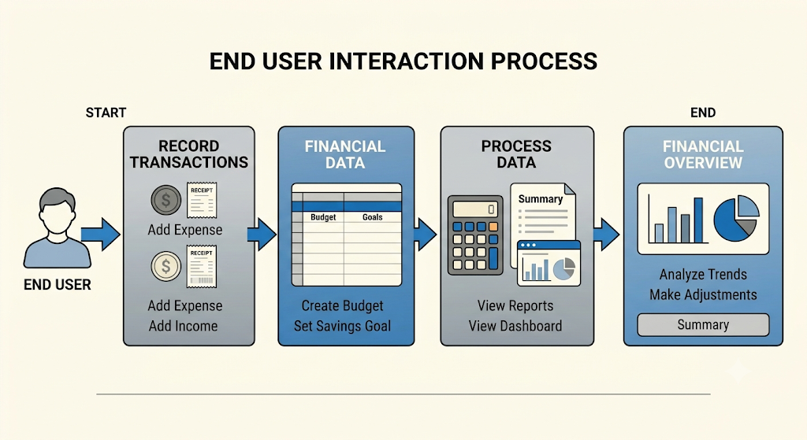
Figure 3.1: SpendWise Use Case Model
Table 3.5: Use Case Description - Record an Expense
Item | Description
Use Case ID | UC-01
Use Case Name | Record an Expense
Actor(s) | End User
Pre-condition | The user has opened the SpendWise application
Main Flow | Open Home Page > choose Add Expense > enter name, amount, date, category and payment method > submit
Alternate Flow | If required data is missing, the form is not submitted until it is completed
Post-condition | The expense appears in All Expenses and the alert email "SpendWise Alert: New Expense Recorded" is sent
Related FR | FR-01, FR-05, FR-08
CHAPTER 4

SYSTEM DESIGN

4.1 System Architecture
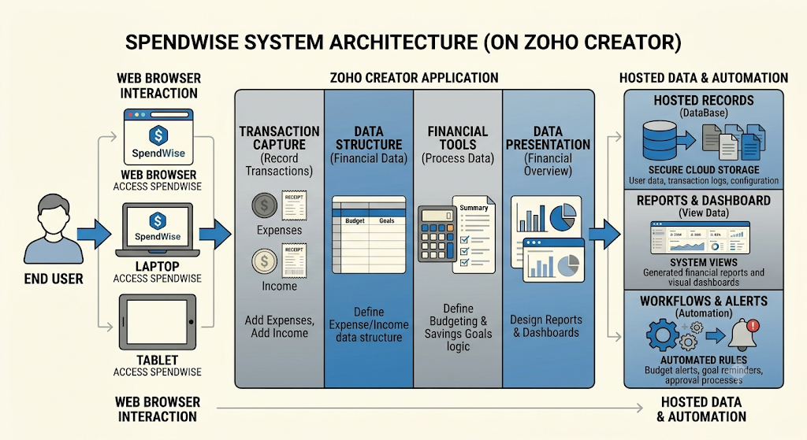
Figure 4.1: SpendWise Layered Architecture
SpendWise is accessed in a web browser through Zoho Creator. The interface layer contains the home page, data-entry forms, reports and dashboard. The data layer maintains four entities: Expenses, Income, Monthly Budget and Savings Goals. The automation layer contains the email notification workflow, and the planned AI Modeler uses historical expense records to generate predictions.

4.2 Data Model
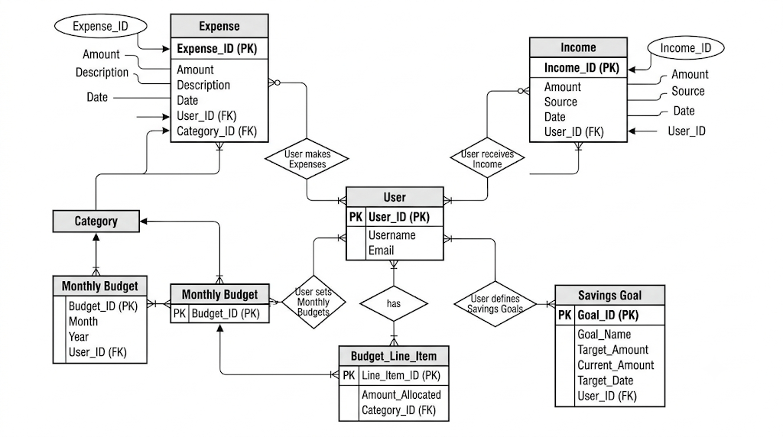
Figure 4.2: Entity-Relationship Model
Table 4.1: Entities and Relationships
Entity (Form) | Key Fields | Purpose | Relationship
Expense | Expense name, Amount, Date, Category, Payment method | Records daily spending | Compared against monthly budget
Income | Income Source, Amount Date | Records earnings | Income overview
Monthly Budget | Budget name, Month, Year, Budget amount, Alert threshold | Plans and monitors spending | Savings Goals
Savings Goal | Budget name, Month, Year, Budget amount, Alert threshold [Goal name, Target amount, Saved amount, Target date | Tracks savings targets | Income

4.3 Form Design
Table 4.2: Field Specifications
Form | Field Label | Field Type | Mandatory | Remarks
Expense | Expense name | [Single Line] | [Yes] | Description of the expense
Expense | Amount | [Currency / Decimal] | [Yes] | Value of the expense
Expense | Date | [Date] | [Yes] | Date of the expense
Expense | Category | [Drop Down] | [Yes] | Used for spending analysis and AI
Expense | Payment method | [Drop Down] | [Yes] | Used for spending analysis and AI
Monthly Budget | Budget name | [Single Line] | [Yes]
Monthly Budget | Month / Year | [Drop Down / Number] | [Yes] | Budget period
Monthly Budget | Budget amount | [Currency / Decimal] | [Yes] | Planned spending limit
Monthly Budget | Alert threshold | [Number / Percent] | [Yes] | Basis for budget warnings

4.4 Process and Workflow Design
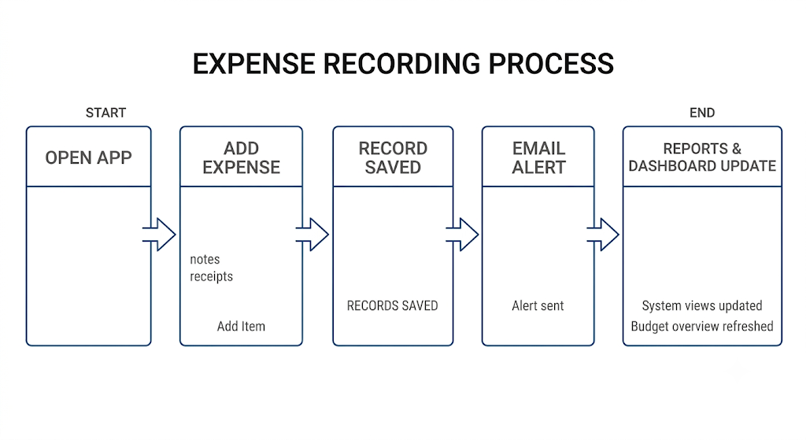
Figure 4.3: Expense Recording and Alert Process
The application workflow is as follows:
- The user opens the SpendWise application.
- The user navigates to the required module.
- Income and expense details are entered through forms.
- Financial records are stored in the application.
- Reports display the recorded information.
- Dashboards provide visual summaries of financial activities.
- Workflows trigger email notifications when configured events occur.
- The planned AI model analyzes historical expense data to generate predictions.

4.5 User Interface and Navigation Design
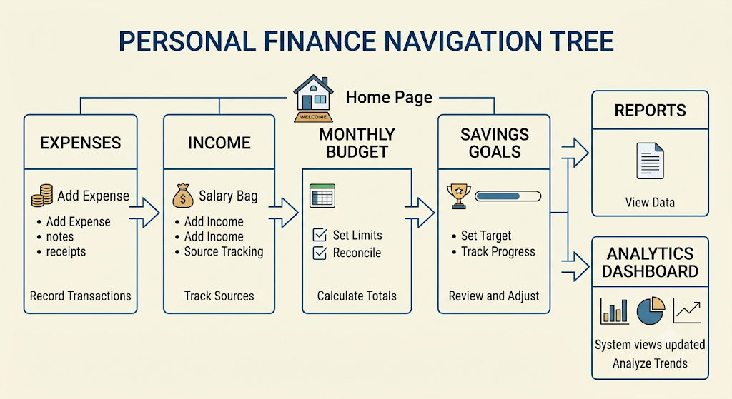
Figure 4.4: Navigation Structure of SpendWise

4.6 Access Control Design
The role-permission matrix below is a proposed design. Confirm the profiles actually configured in Zoho Creator and update the table accordingly.
Table 4.3: Role–Permission Matrix
Component | Owner / Admin | End User (proposed)
Expense records | AEVD | AEVD (own)
Income records | AEVD | AEVD (own)
Monthly Budget records | AEVD | AEVD (own)
Savings Goal records | AEVD | AEVD (own)
Dashboard | V | V (own)
A = Add, E = Edit, V = View, D = Delete.
CHAPTER 5

IMPLEMENTATION

5.1 Application Setup
SpendWise is a Zoho Creator application built with forms for data collection, reports for displaying records, pages for navigation and dashboards, and workflows for notifications. The application has been developed and tested using sample financial records and has reached Production Version 1.0 in Zoho Creator's Environment Management system.
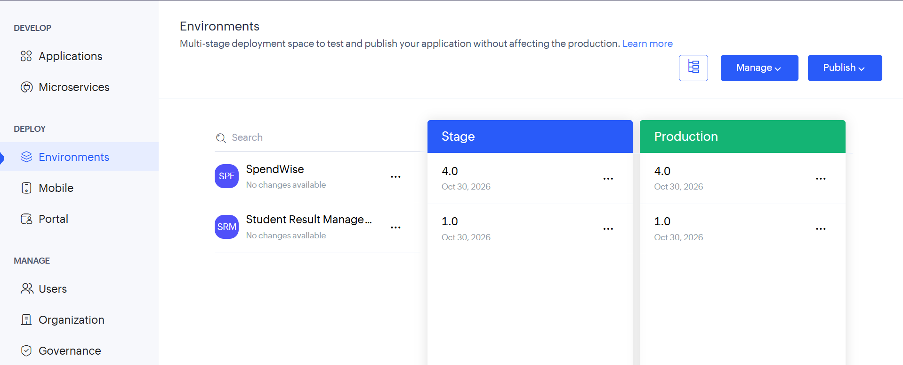
Figure 5.1: Home Page Navigation Hub

5.2 Forms and Data Capture
The application uses structured forms to store financial information. The main data entities are Expenses, Income, Monthly Budget and Savings Goals; these forms provide the foundation for reports, dashboards, workflows and AI-based analytics.
- Expense Management – records daily expenses and stores expense name, amount, date, category and payment method, organizing expenses for easier tracking and analysis.
- Income Management – records different sources of income and helps users understand their total earnings.
- Monthly Budget Management – allows users to create monthly budgets by storing the budget name, month, year, budget amount and alert threshold, so spending can be compared with the plan.
- Savings Goals – allows users to define personal savings goals and monitor progress towards financial objectives.
- 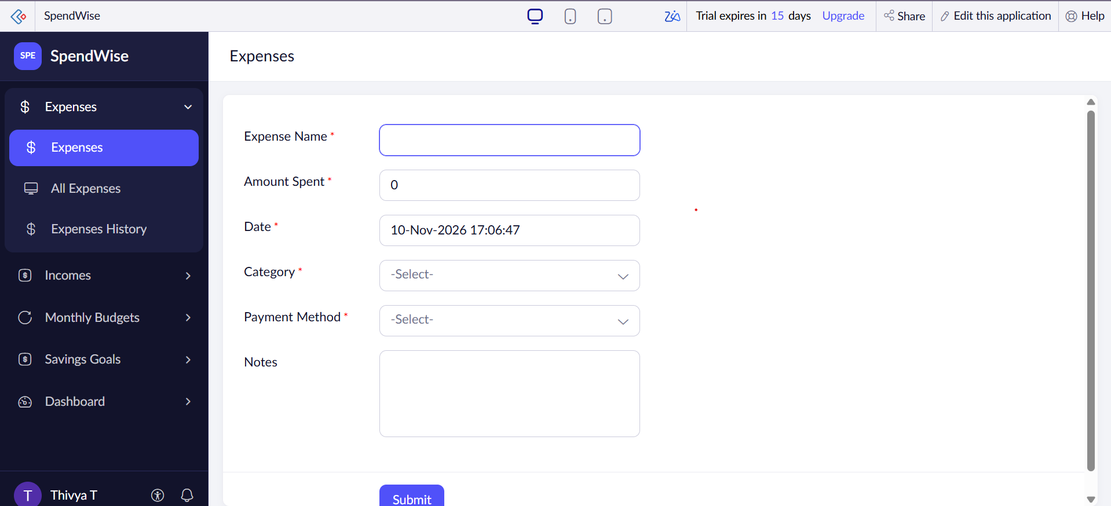
Fig:5.2 Expenses form

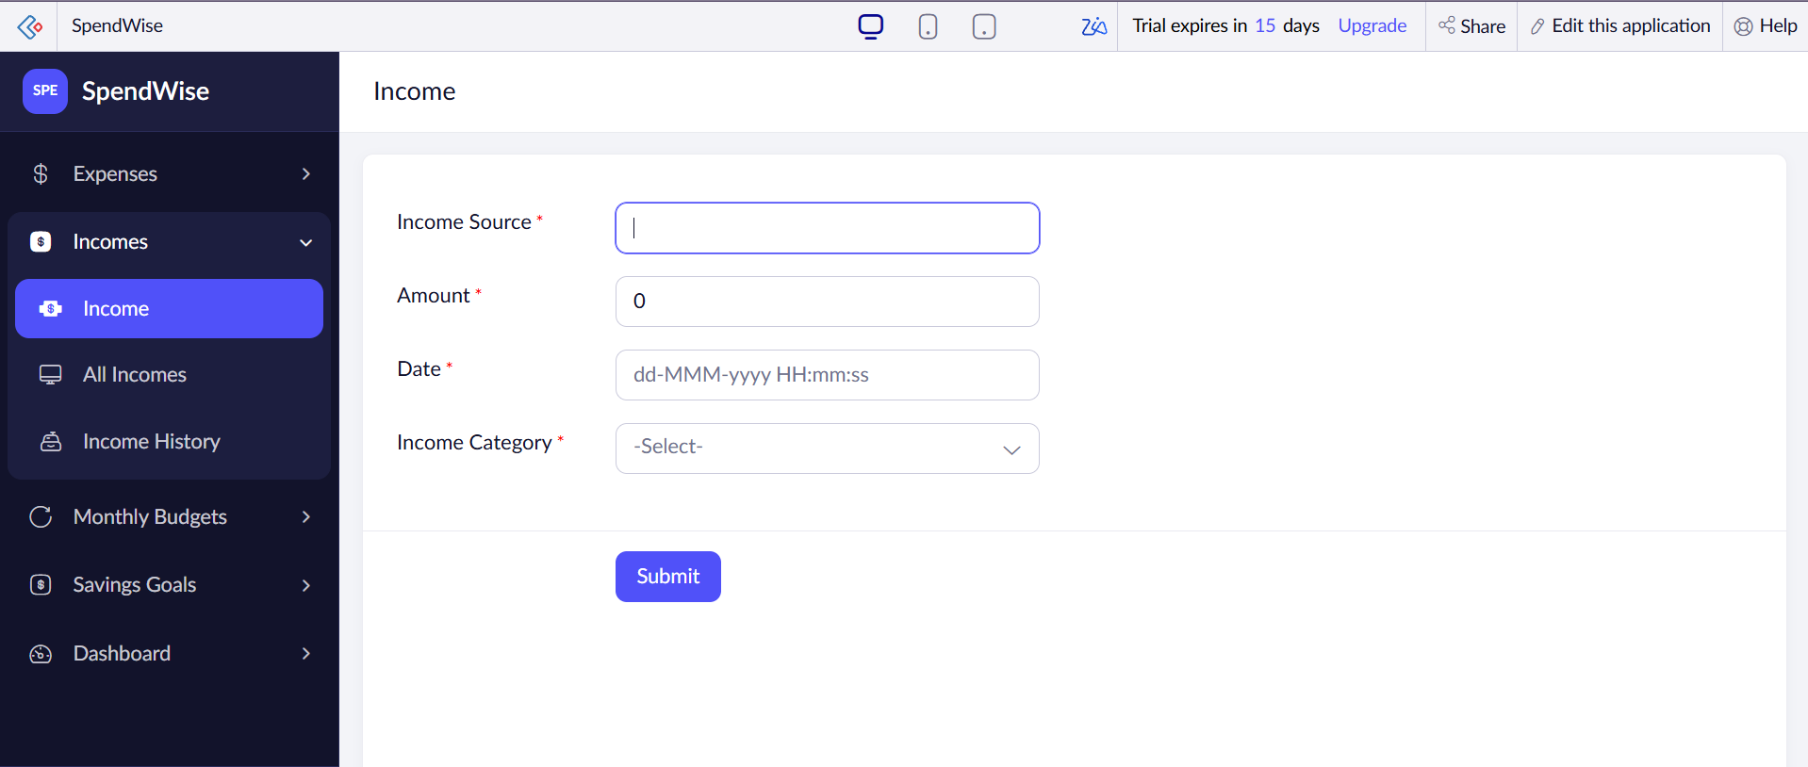
Fig:5.3 Income form

5.3 Reports
The application includes reports for viewing and organizing financial transactions.
Table 5.1: Reports Implemented
Report Name | Type | Source Form | Purpose | Roles
All Expenses | List | Expense | Displays recorded expense details | User
All Incomes | List | Income | Displays recorded income details | User

5.4 Pages and Dashboards
A Home Page Navigation Hub provides a centralized interface for accessing application features. It helps users navigate between modules and access actions such as adding a new expense. The Analytics Dashboard provides visual representations of financial information through charts and is intended to help users understand income, expenses and spending patterns.
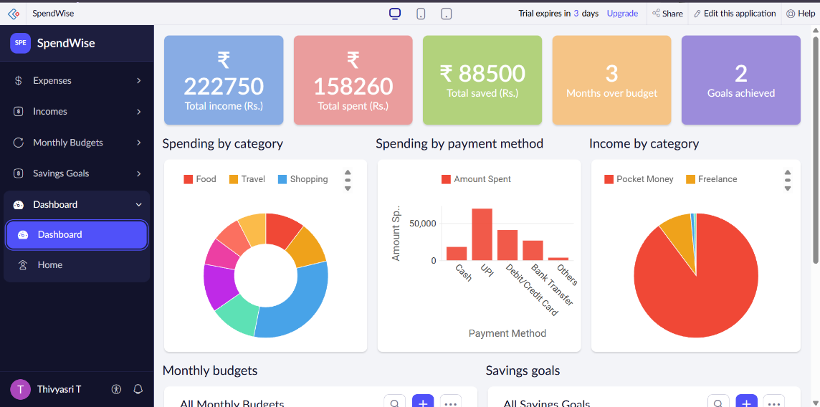

Figure 5.6: Analytics Dashboard

5.5 Deluge Scripting
Table 5.2: Deluge Scripts
Script ID | Location / Trigger | Purpose | Deluge Concepts Used
DS-01 | Expense form – on success | Send "SpendWise Alert: New Expense Recorded" email | sendmail / form variables - confirm

5.6 Workflows and Automation
Workflows are used to automate actions when specific events occur. An existing email notification is configured to send an alert when a new expense is recorded. The notification is titled "SpendWise Alert: New Expense Recorded". Additional notifications are planned.
Table 5.3: Workflows
Workflow Name | Type | Trigger / Event | Action(s) | Status
New expense alert | Form workflow | New expense recorded | Email: SpendWise Alert: New Expense Recorded | Implemented
High-expense alert | Form workflow | Expense exceeds a specified amount | Email alert | Planned
Budget warning | Form / scheduled workflow | Spending reaches 80% and 100% of monthly budget | Email warning | Planned
Savings goal completion alert | Form workflow | Goal reached | Email alert | Planned

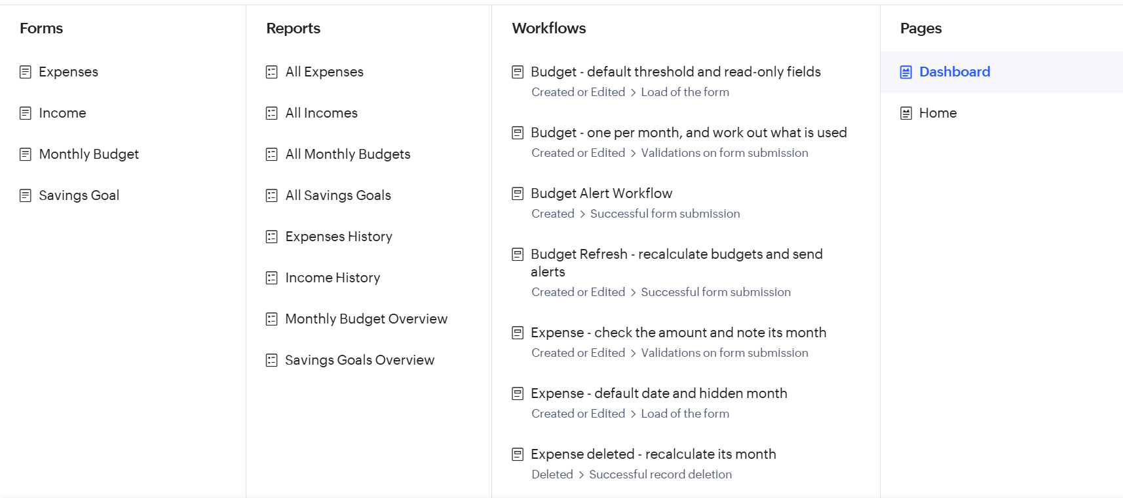
Figure 5.7: Workflow
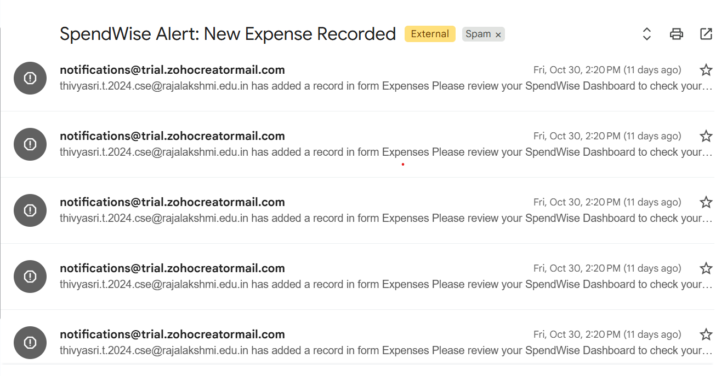
Figure 5.8: Email Received: SpendWise Alert

5.7 Integrations
Table 5.4: Integrations
Integration | Service / Endpoint | Method | Purpose | Status
Email notification | Zoho Creator email | Workflow action | New-expense alert | Implemented
AI Modeler | Zoho Creator AI Modeler | Prediction model | Predict expense amount | Planned

5.8 User Management and Role-Based Access
During the development of SpendWise, the application was managed using the Zoho Creator owner account. No additional users, custom roles, or separate permission profiles were configured.
The owner account has access to the application's development and management features, including forms, reports, dashboards, and workflows. Therefore, the current implementation does not include a fully configured multi-user access control system.

5.9 AI and Analytics Features
The project is being extended with Zoho Creator's AI Modeler. The proposed Prediction model will use historical expense records to learn relationships between expense details such as category, date and payment method, and predict an expense amount. This feature is intended to demonstrate how AI can support financial planning and spending analysis.
Status: the Prediction model still needs to be configured, trained, tested and integrated into the SpendWise application before it can be reported as a completed feature. The Analytics Dashboard provides the descriptive analytics currently available.
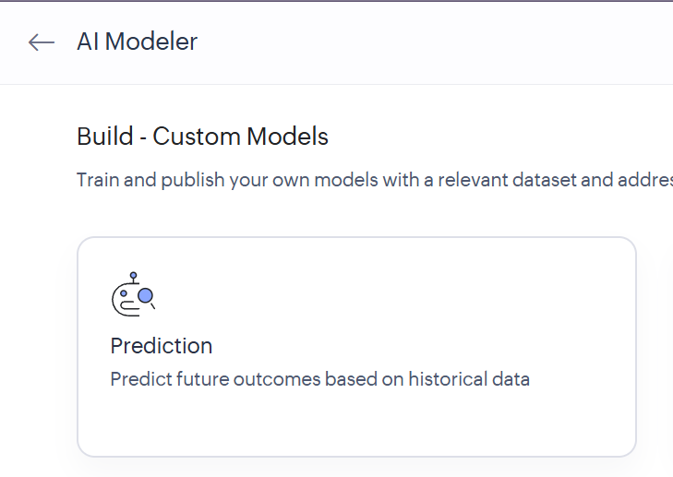
Figure 5.9: AI Modeler - Planned Prediction Model

5.10 Pro-Code Extension
The current application relies on native Zoho Creator capabilities. A future enhancement could use Zoho Creator APIs to integrate with banking or payment data, or add specialized visual widgets.

5.11 Mobile and Portal Access
SpendWise was developed and accessed primarily through the Zoho Creator web interface. The application was deployed to the Production environment (Version 1.0).
Access through the Zoho Creator mobile application and customer portal was not tested as part of the current project implementation. Therefore, mobile application access and customer portal functionality are not considered implemented or verified features of this project.
These capabilities may be explored as future enhancements to improve accessibility and provide users with additional ways to access their personal financial information.

CHAPTER 6

TESTING AND DEBUGGING

6.1 Testing Strategy
The application has been developed and tested using sample financial records. Individual modules and automated features should be tested to verify correct data entry, report generation, dashboard updates and email notifications. The AI prediction feature will require separate training and testing. Record the actual result of each test case below before submission.

6.2 Test Cases
Table 6.1: Test Cases
TC ID | FR Ref. | Test Description | Input / Steps | Expected Result | Status
TC-01 | FR-01 | Add an expense | Submit Expense form with valid data | Record saved | Pass
TC-02 | FR-02 | Add an income | Submit Income form | Record saved | Pass
TC-03 | FR-03 | Create a monthly budget | Submit Budget form | Record saved | Pass
TC-04 | FR-04 | Create a savings goal | Submit Goal form | Record saved | Pass
TC-05 | FR-05 | Expense report | Open All Expenses | New expense listed | Pass
TC-06 | FR-05 | Income report | Open All Incomes | New income listed | Pass
TC-07 | FR-07 | Dashboard refresh | Add expense, open dashboard | Charts reflect new data | Pass
TC-08 | FR-08 | Email notification | Add an expense | Email "SpendWise Alert: New Expense Recorded" received | Pass
TC-09 | FR-01 | Missing mandatory field | Submit blank amount | Validation message shown | Pass
TC-10 | FR-06 | Home page navigation | Click each home page action | Correct form/report opens | Pass

6.3 Debugging Deluge Scripts
Deluge scripts can be debugged by inspecting editor diagnostics, placing minimal info log statements, checking workflow execution history and repeating negative-input tests. During the development of SpendWise, an issue was encountered while integrating the application with Zoho Creator's AI Modeler. The SpendWise application was not appearing in the application selection dropdown when configuring the Prediction model.
Cause: The application had been published to the Stage environment, but a version had not yet been published to the Production environment.
Resolution: The Environment Management section in Zoho Creator was accessed, and SpendWise Version 1.0 was successfully published to Production.
Outcome: After publishing the application to Production, the deployment status displayed Version 1.0. This resolved the missing Production deployment requirement and allowed the AI model integration process to continue.
The existing expense email notification was also checked to ensure that the automated notification was functioning correctly.

6.4 Defect Log
Table 6.2: Defect Log
Bug ID | Description | Root Cause | Fix Applied | Status
DL-01 | SpendWise was not appearing in the AI Prediction Modeler's application dropdown. | The application was published to Stage but not Production. | Published SpendWise Version 1.0 to the Production environment. | Fixed
DL-02 | Expense report fields were not initially configured as intended. | Report configuration and field selection needed adjustment. | Reviewed the report settings and selected the required expense fields. | Fixed

6.5 User Acceptance Testing
Table 6.3: User Acceptance Feedback
User Role Tested | Feedback | Action Taken
End User 1 – Regular User | The expense form is simple to use and allows easy recording of daily expenses. | Reviewed the expense form and its input fields.
End User 2 – Regular User | The application would be more useful if it provided alerts when monthly spending approaches the budget limit. | Identified budget threshold email notifications as a future enhancement.
CHAPTER 7

DEPLOYMENT, SECURITY AND GOVERNANCE

7.1 Environments and Deployment Strategy
The SpendWise application has reached Production Version 1.0 in Zoho Creator's Environment Management system. Changes are made in the development environment, and the tested version is promoted to production.
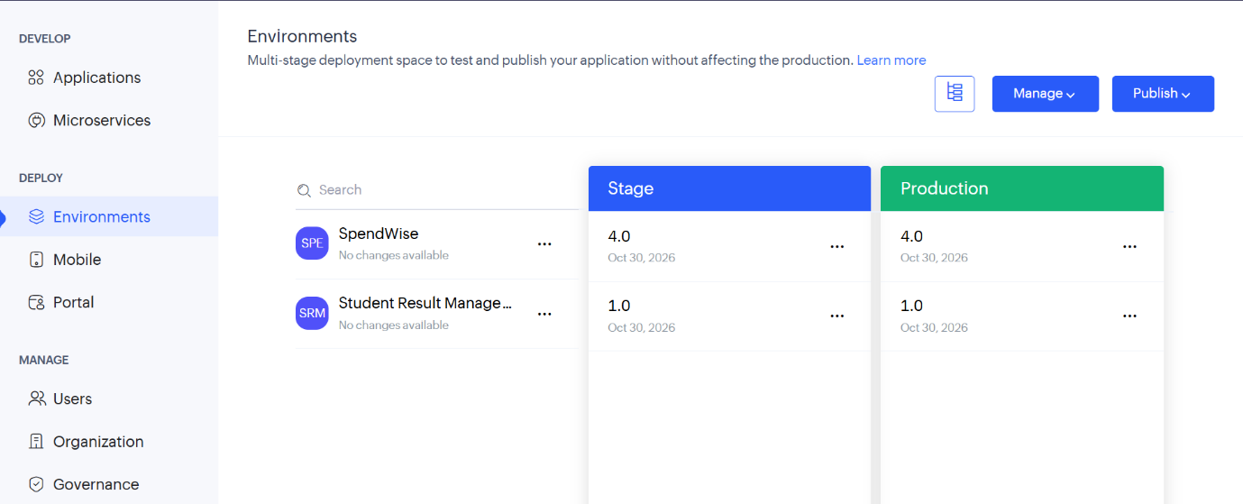
Figure 7.1: Environment Management - Production Version 1.0
Table 7.1: Deployment Checklist
S.No. | Checklist Item | Done (✓)
1 | Forms for expenses, income, budgets and savings goals created | ✓
2 | Sample financial records entered | ✓
3 | Reports (All Expenses, All Incomes) created | ✓
4 | Home page and Analytics Dashboard created | ✓
5 | New-expense email notification configured | ✓
6 | Production Version 1.0 reached in Environment Management | ✓
7 | AI Prediction model trained and integrated | ✓

7.2 Performance Optimisation
Suggested practices include limiting unnecessary report columns, using focused filters, avoiding redundant calculations and using native Creator aggregate charts.

7.3 Security Features
Financial data is sensitive, so access should be limited to authorized users. The table below distinguishes the controls that should be configured; update the status column to match what was actually set up.
Table 7.3: Security Controls
Security Control | Where Applied | Threat Mitigated | Status
Creator account login | Application access | Unauthorized access | Confirm
Mandatory fields / validation | Forms | Bad or missing inputs | Confirm
Record-level permissions | Permission profiles | Viewing or editing others' data | Confirm
Change history / audit | Application settings | Unauthorized modification | Confirm

7.4 Governance and Administration
Recommended governance includes naming conventions for forms and fields, periodic export of records, review of users with editing access, controlled promotion of changes through environments, and release notes for each production version.
CHAPTER 8

RESULTS AND DISCUSSION

8.1 Application Output
A representative scenario begins on the Home Page, where the user chooses to add a new expense. After the form is submitted, the record appears in the All Expenses report, the Analytics Dashboard reflects the updated figures, and the email alert "SpendWise Alert: New Expense Recorded" is sent.
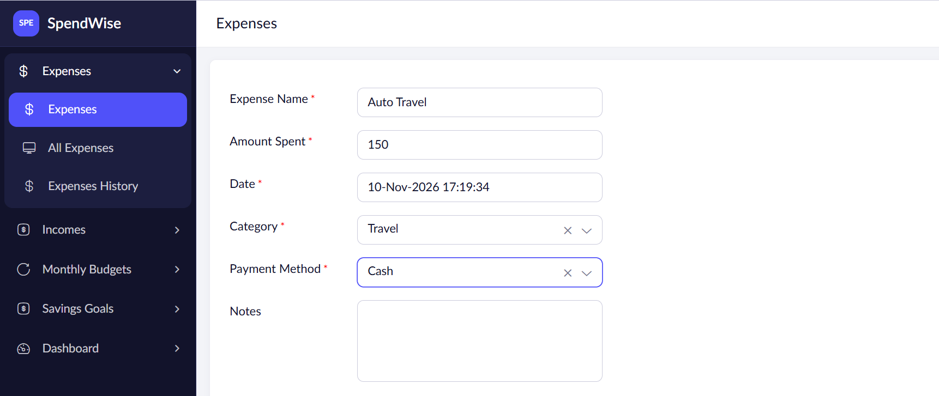
Figure 8.1: Scenario Step 1 - Add an Expense

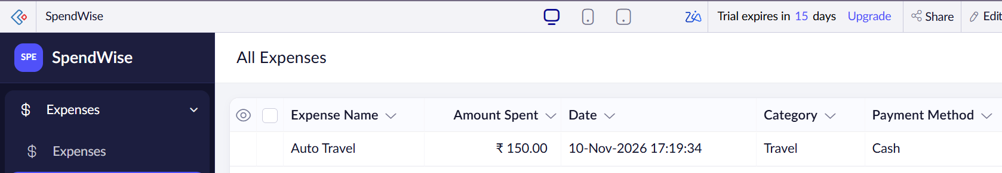
Figure 8.2: Scenario Step 2 - Records in Reports
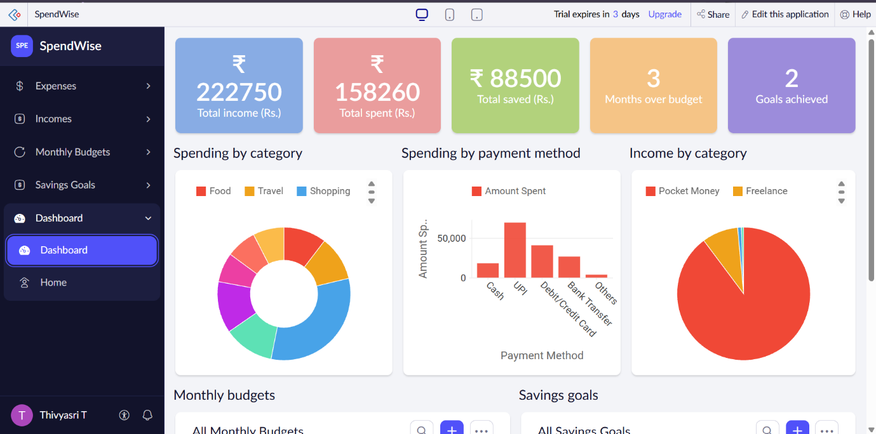
Figure 8.3: Scenario Step 3 - Dashboard Update

8.2 Achievement of Objectives
Table 8.1: Mapping of Objectives to Outcomes
Objective (Sec. 1.3) | Implemented Through | Outcome / Status
Centralized finance application | Four linked modules and home page | Achieved
Record and organize income and expenses | Expense and Income forms; All Expenses and All Incomes reports | Achieved
Create and monitor monthly budgets | Monthly Budget form with alert threshold | Budget records achieved; automated warnings planned
Track savings goals and progress | Savings Goals form | Achieved
Generate reports and visual dashboards | Reports and Analytics Dashboard | Achieved
Automate notifications | New-expense email workflow | Partially achieved; other alerts planned
AI-based prediction and analytics | AI Modeler Prediction model | Planned; not yet complete
Improve financial awareness | Dashboard charts and alerts | Supported; user feedback pending

8.3 Comparison with the Existing System
Table 8.2: Existing System versus Proposed Application
Parameter | Existing System | Proposed Application | Improvement
Data storage | Notes / separate spreadsheets | Linked Creator forms | Single application
Budget tracking | Manual calculation | Budget records with alert threshold | Structured budgets
Awareness of spending | After the fact | Email alert on each new expense | Immediate notification
Spending summary | Manual totals | Dashboard charts | On-screen visual summary
Prediction | None | AI Modeler (planned) | Future capability

8.4 Limitations of the Low-Code Approach
Zoho Creator reduces the volume of custom code but ties the application to platform components and account plan limits. Native reports and charts can have layout constraints, and complex analytics, custom notification logic and deep integrations may require Deluge scripting, connections or external services. The AI Modeler also depends on having enough quality historical data to train a useful model.

8.5 Reflection on the No-Code → Low-Code → Pro-Code Spectrum
SpendWise mainly uses the no-code and low-code parts of the spectrum: configured forms, reports, dashboards and workflows, with Deluge for notification logic. Pro-code could be justified later for bank-statement import, advanced forecasting or bespoke interfaces. These are architectural options, not completed features.
CHAPTER 9

CONCLUSION AND FUTURE ENHANCEMENTS

9.1 Conclusion
SpendWise demonstrates the practical application of low-code development using Zoho Creator. It combines financial data collection, reporting, visualization and automation in one application. The proposed integration of AI-based prediction further extends the system's capabilities by introducing intelligent analysis of historical financial records. The project shows how low-code platforms can be used to develop practical applications while incorporating automation and emerging AI capabilities.

9.2 Future Enhancements
- High-expense alerts when a transaction exceeds a specified amount.
- Budget warnings when spending reaches 80% and 100% of the monthly budget.
- Savings goal completion notifications.
- Automated weekly or monthly financial summary emails.
- Multi-currency support.
- Financial report exports in PDF format.
- Improved AI-based spending predictions and personalized recommendations.

9.3 Learning Outcomes and Career Relevance
The project provides experience in data modelling, form and report configuration, dashboards, workflow automation, environment-based deployment and the basics of AI-assisted analytics. These competencies apply to low-code development, business analysis, workflow consulting and application administration. More advanced skills can follow through deeper Deluge scripting, API connections and secure deployment practices.

REFERENCES
[1] Zoho Corporation, "Understanding Forms," Zoho Creator Help. [Online]. Available: https://help.zoho.com/portal/en/kb/creator/developer-guide/forms/the-concept-of-forms/articles/form-component.
[2] Zoho Corporation, "Configuring Deluge Script for Form Workflows," Zoho Creator Help. [Online]. Available: https://help.zoho.com/portal/en/kb/creator/developer-guide/workflows/create-and-manage-form-workflows/articles/configuring-deluge-script-for-form-workflows.
[3] A. Bucaioni, A. Cicchetti and F. Ciccozzi, "Modelling in low-code development: A multi-vocal systematic review," Software and Systems Modeling, vol. 21, pp. 1959-1981, 2022, doi: 10.1007/s10270-021-00964-0.
[4] D. Pinho, A. Aguiar and V. Amaral, "What about the usability in low-code platforms? A systematic literature review," Journal of Computer Languages, vol. 74, art. 101185, 2023, doi: 10.1016/j.cola.2022.101185.
[5] Zoho Corporation, "AI Modeler," Zoho Creator Help. [Online].

APPENDIX A – ZOHO CREATOR FEATURE COVERAGE CHECKLIST
Y = implemented and evidenced in this report; N = not implemented or not evidenced; Planned = documented as future work; Partial = only basic controls in place.
Table A.1: Feature Coverage Checklist
Unit | Zoho Creator Feature | Done | Where in the Application | Report Section
I | Application created & sections / menu organised | Y | SpendWise app, Home Page | 5.1
II | Forms with ≥ 8 distinct field types | N | Fewer than 8 field types documented (Table 4.2) | 5.2
II | Lookup field (relationship between forms) | N | Not implemented / not evidenced | 4.2, 5.2
II | Subform (parent–child data) | N | Not implemented | 4.2, 5.2
II | Field validations / layout rules | Y | Mandatory fields; validation message (TC-09) | 4.3, 5.2, 6.2
II | List report with filter, grouping, custom action | Y (list reports) | All Expenses, All Incomes | 5.3
II | Kanban / Calendar / Timeline / Map report | N | Not implemented | 5.3
II | Pivot table / chart report | N | Charts appear on the dashboard page only | 5.4
II | Page / dashboard built with UI Builder | Y | Home Page, Analytics Dashboard | 5.4
II | Deluge – form events | Y | Expense form - on success (DS-01) | 5.5
II | Deluge – functions, fetch, loops, collections | N | Not implemented | 5.5
II | Email / in-app notifications | Y | New-expense email alert | 5.6
II | Form workflow | Y | New-expense alert workflow | 5.6
II | Scheduled workflow | Planned | Planned (budget / summary alerts) | 5.6
II | Approval process | N | Not implemented | 5.6
II | Blueprint | N | Not implemented | 5.6
II | Batch / report workflow | N | Not implemented | 5.6
II | Testing & debugging evidence | Y | Chapter 6 (test cases, defect log, UAT) | 6
III | Integration with a Zoho service | N | Native email action only; AI Modeler planned | 5.7
III | Connection / REST API call (invokeurl) | N | Not implemented | 5.7
III | Webhook or Creator REST API | N | Not implemented | 5.7
III | Users, roles and permission profiles | N | Owner account only; no custom roles configured | 5.8
III | Record-level access criteria / customer portal | N | Not configured; portal not tested | 5.8, 5.11
III | Zia / AI feature | Planned | AI Modeler Prediction (not complete) | 5.9
III | Analytics (charts / Zoho Analytics) | Y | Analytics Dashboard | 5.9
IV | Performance optimisation applied & measured | N | Suggested practices only; not measured | 7.2
IV | Deployment across environments | Y | Production Version 1.0 | 7.1
IV | Security controls (encryption, OAuth, permissions) | Partial | Account login; mandatory-field validation | 7.3
IV | Governance (audit trail, administration) | N | Recommended practices only | 7.4
V | Pro-code extension (Catalyst / widgets / custom functions) | N | Native Creator features only; future scope | 5.10
V | Low-code limitations & spectrum analysis | Y | Discussion | 8.4, 8.5
— | Mobile app / portal access | N | Not tested | 5.11

APPENDIX B – COURSE OUTCOME MAPPING
Table B.1: Mapping of Course Outcomes to Report Chapters
CO | Course Outcome Statement | Evidenced In | Self-Assessed Level
CO1 | Explain the principles, architecture, and business value of low-code application development using Zoho Creator. | Ch. 1, 2
CO2 | Develop business applications using Zoho Creator forms, reports, workflows, and Deluge scripting. | Ch. 4, 5 (5.1–5.6), 6
CO3 | Integrate Zoho Creator applications with Zoho services and external systems using APIs, connections, and role-based security. | Ch. 4.6, 5.7–5.9
CO4 | Deploy, secure, and manage Zoho Creator applications across development and production environments following governance best practices. | Ch. 7
CO5 | Evaluate low-code development strategies, AI-assisted application development, and the transition from citizen developer to professional developer. | Ch. 5.9, 5.10, 8.4, 8.5, 9.3

APPENDIX C – COMPLETE DELUGE SOURCE CODE

C.1 Confirmed custom script inventory
For sending mail:
sendmail
[
from : zoho.adminuserid
to : "your-email@example.com"
subject : "SpendWise Alert: New Expense Recorded"
message : "Hello!\n\nA new expense has been recorded in SpendWise.\n\nExpense Name: " + input.Expense_Name + "\nAmount: Rs. " + input.Amount.toString() + "\nCategory: " + input.Category + "\n\nPlease check your SpendWise application for more details.\n\nRegards,\nSpendWise"
];

C.2 Proposed automation extensions (not implemented)
- High-expense alert: trigger when an expense amount exceeds a set limit.
- Budget warning: compare month-to-date expenses with the budget at 80% and 100%.
- Savings goal completion alert: notify when the saved amount reaches the target.
- Weekly / monthly summary email via a scheduled workflow.

APPENDIX D – USER MANUAL

D.1 Accessing the Application
Open the authenticated Zoho Creator application in a desktop browser. An authorized Zoho account is required; no passwords are included in this report.

D.2 Instructions for the End User
- From the Home Page, choose the required action (for example, Add Expense).
- Fill in the form fields (for example, expense name, amount, date, category and payment method) and click Submit.
- Open All Expenses or All Incomes to review recorded transactions.
- Create a monthly budget with the budget name, month, year, amount and alert threshold.
- Open the Analytics Dashboard to review income, expenses and spending patterns.
- Check your email for the "SpendWise Alert: New Expense Recorded" notification after adding an expense.

D.3 Instructions for the Administrator
- Open the application in edit mode to maintain forms, reports, pages and workflows.
- Use Environment Management to promote tested changes to production.

APPENDIX E – EVALUATION RUBRIC
(For Examiner Use Only)
Student Name: THIVYASRI T Register No.: 2116240701571
Project Title: SpendWise Date: ________________
Table E.1: Evaluation Rubric for the Individual Project
S.No. | Criterion | Indicators | Max. Marks | Marks Awarded
1 | Problem Definition & Requirement Analysis | Clarity of problem, measurable objectives, complete FR/NFR, use cases | 10
2 | System Design | Architecture, ER/data model, form specifications, workflow design, permission matrix | 10
3 | Forms, Reports & Pages | Variety of field types, lookups/subforms, report types, UI Builder dashboards | 15
4 | Deluge Scripting & Workflows | Correctness and depth of scripts; form, schedule, approval, Blueprint, batch workflows | 15
5 | Integration, RBAC & AI | Zoho/external integrations, connections, roles & permissions, Zia/analytics | 10
6 | Testing, Deployment, Security & Governance | Test coverage, environments, optimisation, security controls, audit | 10
7 | Live Demonstration | End-to-end working of the application across roles; feature checklist verified | 15
8 | Project Report | Adherence to template and format, clarity, figures, references | 5
9 | Viva-Voce | Understanding of the platform, design decisions and low-code concepts | 10
 | TOTAL |  | 100
Table E.2: Performance Level Descriptors
Level | % of Max. Marks | Descriptor
Excellent | 90–100 | Feature implemented completely, correctly and beyond the basic requirement; student explains design choices confidently.
Good | 70–89 | Feature implemented correctly with minor gaps; explanation adequate.
Satisfactory | 50–69 | Feature partially implemented or works only for the main path; limited explanation.
Needs Improvement | < 50 | Feature missing, non-functional or not understood by the student.

Signature of Internal Examiner: ______________________ Name: ____________________
Signature of External Examiner: ______________________ Name: ____________________

APPENDIX F – VIVA-VOCE RECORD SHEET
(For Examiner Use Only)
Student Name: THIVYASRI T Register No.: 2116240701571
Department / Section: ____________ Date of Viva: ____________
Application URL Verified: Yes / No Demo Duration: ______ min
Table F.1: Viva-Voce Questions and Responses
Q.No. | Question / Topic Asked | Unit | Response (E / G / S / NI) | Remarks
1
2
3
4
5
6
7
8
E – Excellent G – Good S – Satisfactory NI – Needs Improvement
Table F.2: Marks Summary
Component | Max. Marks | Marks Awarded
Criteria 1–8 (Appendix E) | 90
Viva-Voce | 10
TOTAL | 100

Examiners' Remarks:
____________________________________________________________________
____________________________________________________________________

INTERNAL EXAMINER: ____________________ EXTERNAL EXAMINER: ____________________

